Functional Specification – Handle Flight Disruptions

Revision History
Version | Date | Description | Author
0.1 | 23-May-24 | Draft Version | Vinod Madallapalli

Table of Contents
1. INTRODUCTION 4
1.1. Purpose 4
1.2. Project Overview 4
1.3. Assumptions 4
2. PROPOSED SYSTEM 6
3. IMPLEMENTATION MECHANISM OF REQUIREMENTS 7
3.1. Business Requirements 7
3.2. Functional Requirements 7
4. FUNCTIONAL DESCRIPTION 11
4.1. Functional Description 11
4.1.1. UI for user administration (Create UI in next phases. In Phase 1, manage with JSON or entering data in DB manually) 11
4.1.2. UI to create exception flight list. 11
4.1.3. UI to approve or reject re-accommodation 14
4.1.4. Provision to update configurable parameters: 15
4.1.5. Re-accommodation Engine 18
5. Systems/Technologies 23

INTRODUCTION

Purpose
This document delineates the functionality and process flow essential for effectively managing flight disruptions. It provides a comprehensive explanation of the business and functional requirements, as well as the business and processing logic necessary for the system's operation.

Project Overview
The objective of this application is to handle disruptions performing involuntary re-accommodation in the following scenarios.
- Re-accommodation in case of Flight Cancellation:
When a flight is cancelled in Jeppesen (by OCC), the cancellation cascades to Navitaire re-accommodation is to be provided.

- Flight Reschedule:
When a flight’s ETD is changed in Jeppesen (by OCC), the information cascades to Navitaire re-accommodation is to be provided in case of misconnection – while customer has the option to choose alternate flight via Plan B for all other scenarios.

Flights affected by a time change resulting in a departure delay of 2 or more hours or advance departure minimum by 1 hour.
The requirement entails accommodating impacted passengers on the best-suited alternate flights. and intimating customers of the change by suitable means.

Assumptions
- OCC to update exception table whenever required before making changes in Jeppesen. System doesn’t enforce this.
- All external applications/servers like Kafka, GO-NOW (Navitaire), AD account validation, Sales force, UCG, Plan B are live and available.
- If specific TO flight is entered in exception table, then it is assumed that both FROM and TO flights have routing, same number of legs.
- Consider flights only in the window D-48 to D-72 hours before scheduled departure time for phase 1.
- Search alternate flights up to +(-) days manually configurable of impacted flight departure date for phase 1.
- In case of reschedule, delay should be at least 2 hours or advance departure by minimum 1 hour for phase 1.
- Re-accommodation will be performed only from 6E-to-6E flights.
- No maximum limit on duration between two connecting flights while re-accommodating.

PROPOSED SYSTEM

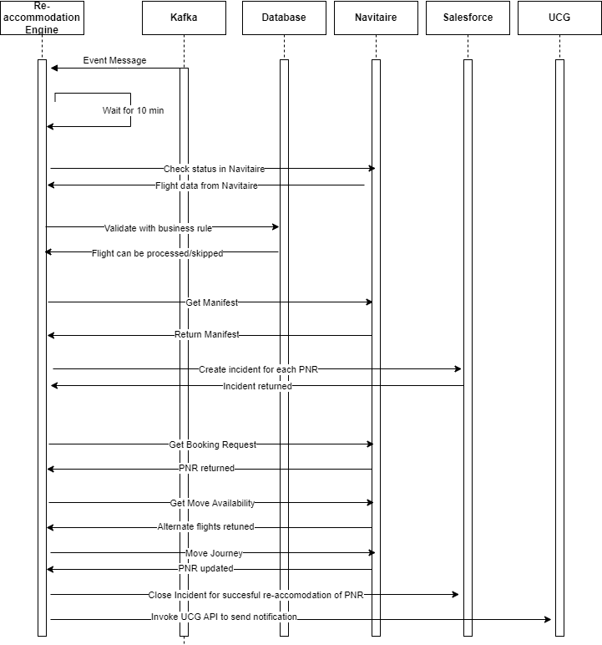

IMPLEMENTATION MECHANISM OF REQUIREMENTS

Business Requirements
ID | Business Requirement
BR1 | Setup business rules, users and parameters.
BR2 | Application to do automatic re-accommodation using preset rules/parameters
BR3 | Notify stakeholders on automatic re-accommodation
BR4 | Update PNRs with alternate flights
BR5 | Notify customers with new flight details
BR6 | Customer to check and accept, change or cancel re-accommodated flight

Functional Requirements
BR ID | FR ID | Functional Requirement
BR1 | 1 | Screen for user login.
 | 2 | Screen for user management.
 | 3 | Screens to create, modify, view, and delete parameters.  - Re-accommodation to be done from 6E-to-6E flights.  - Minimum Connecting Time (MCT) at each airport.  - Window for flight eligibility. (D-48 to D-72)  - Number of days up to which in future / past dates flights to be searched (+- days)  - Minimum and maximum hours of delay/advance departure.  - Number of seats to be left untouched on selected alternate flight.  - List of SSR/items to be checked to skip re-accommodation.  - Prioritise passenger type.
 | 4 | Screens to create, View exception flights.  - Flights on which NO ACTION REQUIRED  - Flights onto which no re-accommodation to be performed.  - Flight to be re-accommodated and specific re-accommodated TO flight.  - Flight to be re-accommodated on specified alternate route flights (Not for Phase 1)  - Flights with specified routing for which NO ACTION REQUIRED (Not for Phase 1)

BR ID | FR ID | Functional Requirement
BR2 | 1 | Read message from Kafka.
 | 2 | Validate flight against parameters.  - Window for flight eligibility. (D-48 to D-72)  - Minimum and maximum hours of delay/advance departure.
 | 3 | Validate flight data against exception flight list database.  - Flights on which NO ACTION REQUIRED  - Flight to be re-accommodated and specific re-accommodated TO flight.  - Flight to be re-accommodated on specified alternate route flights (Not for Phase 1)  - Flights with specified routing for which NO ACTION REQUIRED (Not for Phase 1)
 | 4 | Validate flight data against Navitaire  - Invoke API to get flight data
 | 5 | Screen to display disrupted flight with Approve and Reject Icon  This is based on business rule AUTO RE-ACCOMMODATION.  If set to YES, then no screen to be displayed and proceed with re-accomodation  If set to NO, manual intervention required by OCC team and approve or reject re-accomodation process
 | 6 | Process business rules for each flight.  - Invoke API to get flight Manifest.  - Invoke API “GetMoveAvailabilityRequest” to get alternate flights.  - Select alternate flight as per priority tables given.  - Create ticket with Salesforce for each PNR.  - Log flight and PNR ton log file. PNR, Original flight, alternate flight, status of re-accommodation, reason for re-accommodation needs to be logged.  - If connecting flight can’t be retained, then re-accommodate PNR on alternate connecting flights as well.
 | 7 | Generate reports and queue to OCC

BR ID | FR ID | Functional Requirement
BR3 | 1 | Notify internal stake holders on email.  - initiate of re-accommodate process.  - skip of re-accommodation process due to business rule (specified)

BR ID | FR ID | Functional Requirement
BR4 | 1 | Invoke API “MoveJourneyBookingRequest” to re-accommodate PNR.
 | 2 | Close ticket opened with Salesforce for successful re-accommodation of PNR.
 | 3 | Add PNR to successful list, excluded list, exception list or error list for report generation.

BR ID | FR ID | Functional Requirement
BR5 | 1 | Notify customer on re-accommodation through UGC.
 | 2 | Create new template on UGC.

BR ID | FR ID | Functional Requirement
BR6 | 1 | Existing application Plan B can handle this requirement.

FUNCTIONAL DESCRIPTION
Functionalities for user administration, business rules creation, Re-accommodation needs to be developed.

Functional Description

UI for user administration (Create UI in next phases. In Phase 1, manage with JSON or entering data in DB manually)
- Create roles.
- Screen to create role, modify and View.
- Screen to have field – Role name, Tasks can be performed.
- Roles are Admin and Basic
- As of now, only provision needed for multiple roles but both roles are similar with same kind of access.
- Roles to be stored in database.

- Assign roles to user.
- Screen to enter username and choose role.
- User Name (Email) and Role to be stored in database.

- Screen to login.
- Email and Password to be entered.
- Validate against AD account.

UI to create exception flight list.
- Enter exception flight for which re-accommodation not to be performed. Flight details carrier code, flight number, flight suffix, flight date at origin city or range of dates, origin, and destination.
- Enter exception flight and alternate flight on to which re-accommodation to be done. In this case, re-accommodation is done on to only specified flight. Here fields are carrier code, flight number, flight suffix, date at origin and origin city for both FROM flight and TO flight.
- Enter exception flights on to which re-accommodation not to be performed. Here fields are carrier code, flight number, flight suffix, date at origin or range of dates and origin city.
- Above 3 types of exceptions can be entered with excel upload as well (if time permits in Phase I else in later phases)
- Validate if user authorized to make changes.
- Log all changes done in these screens.
- Store all exception flight details in database.
- Screen to view exception flights.

SCREEN TO CREATE

NO ACTION REQUIRED Excel Upload

Airline code

Flight Number/Suffix
Date (range) | -
Origin

Destination

Re-accommodate to specific flight Excel Upload

Disruption Flight
Airline code

Flight Number/Suffix
Date

Origin

Destination

Re-accommadation Fligt
Airline code

Flight Number/Suffix
Date

NO MOVE ONTO Excel Upload

Airline code

Flight Number/Suffix
Date (Range) | -
Origin

Destination

UI to View

Date

Origin
Destination

Type (NO ACTION REQUIRED, NO MOVE ONTO, SPECIFIC MOVE)

Report with details of flights to be displayed

UI to approve or reject re-accommodation
- Fields on screen include Carrier code, Flight Number, Suffix, date at origin city, origin- reason for re-accommodation (cancelled, delay, advanced departure time) and buttons to APPROVE and REJECT

- Validate to check if user authorized to approve or Reject

Disrupted Flights
Airline | Flight Number | Date | Org | Dest | Remarks | Approve  /Reject | Submit
6E | 111 | 30 May 24 | DEL | BOM |  | Dropdown box | Button

Provision to update configurable parameters:
(Screen required in next phases. In Phase 1, JSON object or enter data manually in DB)
- Screen to modify, view parameters.
- Minimum Connecting Time (MCT) at each airport.
- Window for flight eligibility. (D-48 to D-72). Only flight falling in this range are considered for re-accommodation.
- Number of days up to which in future / past dates flights to be searched (+- days). Flights of these days are considered for alternate flights (onto which re-accommodation will be done)
- Minimum and maximum hours of delay/advance departure. If maximum is blank, then no limit of maximum delay/advancement.
- Number of seats to be left untouched on selected alternate flight. Not to re-accommodate PNRs on to new flights to its full capacity. Specified number of seats to be left for regular bookings.
- List of SSR/items to be checked.
- Prioritize pax type for re-accommodation.
- AUTO PROCESSING – Switch to check if manual intervention needed by OCC team to proceed with re-accommodation. If AUTO PROCESSING is NO, system will proceed with re-accommodation. If YES, OCC team needs to log in and click on APPROVE button.

- Check user if authorized.
- Log all changes done on configured parameters with user who changed, date and time.
- Update database table.

Parameters
MCT Excel Upload Excel Download

Airport Code | D TO D | DO TO I | I TO D | I TO I

Window for flight eligibility
Min hours | Max hours

No of days of flights in the past/future to be searched for
Past | Future

Minimum and Maximum hours of delay
Min | Max

Minimum and Maximum hours of Departure advancement
Min | Max

No of seats to be untouched

SSRs to check |  | Excel Upload | Excel Download

AUTO PROCESSING

SUBMIT

Re-accommodation Engine
- Re-accommodation Process Trigger:

- The process is triggered by an event on Kafka (application to subscribe to the topic). Allow a cooling period of 10 minutes to let processing on Navitaire be completed before starting the re-accommodation process.

- Flight Validation:

- Validate the flight data against parameters to ensure it falls within the eligible window (D-48 to D-72).

- For rescheduled flights, check that delays or advances in departure time are within the limits of minimum and maximum delay/advance departure.

- Flight Data Synchronization:

- Check flight data in Navitaire by invoking the API. If the data is not in sync with the message from Kafka, wait for 10 minutes.

- Perform a second attempt to check flight data with Navitaire by invoking the API. If the data is still not in sync, terminate the process and send a notification to the OCC team.

- Exception Handling:

- Check if the flight is in the exception flight list under "NO ACTION REQUIRED." If it is, terminate the process.
- Send a notification to all OCC team members upon the initiation of the process.

- Re-accommodation Authorization:

- If the parameter "AUTO PROCESSING is ON, proceed with re-accommodation. Otherwise, stop processing and require the OCC team to log in and initiate the process manually.

- Flight Manifest Retrieval:

- Get the flight manifest from Navitaire by invoking the API.
- Sort PNRs as per the criteria given (refer to the scope document).
- Store Manifest in Database
- Store original Manifest in NoSQL database.

- Incident Creation:

- For each PNR, open an incident in Salesforce.

- Alternate Flight Selection:

- If the "TO" flight is mentioned in the exception table, re-accommodate all PNRs onto the specified "TO" flight only.
- Invoke the API to get a list of alternate flights available.
- Skip flights present in the exception table under the section “flight on to which re-accommodation not allowed.”
- If a PNR has a connecting flight, select an alternate flight aiming to retain the existing connecting flight.
- If alternate flights are not available to retain the existing connecting flight, re-accommodate the PNR on connecting flights as well.
- Choose flights closure to disrupted flight scheduled departure time.
- At the beginning take flights prior to disrupted flight scheduled departure time. Flights up to 5 hours earlier should be taken.
- Next take flights after departure time of disrupted flight. This can be extended till 7 days in future.

- Re-accommodation Based on Disruption Type:

- For delayed flights, search for flights prior to the disrupted flight's departure time to retain the connection.
- For advanced departure times, search for flights with later departure times than the disrupted flight.
- Choose alternate flights closest to the departure time of the disrupted flight.

- Re-accommodation Execution:

- Invoke the API to re-accommodate PNRs if enough seats are available. Leave the specified number of seats (as per the parameter) untouched for normal booking.
- Continue searching for flights within the specified +/- days parameter (past and future dated flights).

- Database and Incident Management:

- Insert PNRs in the database with the status of re-accommodation.
- Close the incident in Salesforce once the PNR is re-accommodated.
- Notify the customer by invoking the API of the UCG application.

- Logging and Reporting:

- Log each processed flight and each processed PNR.
PNR, Original flight, alternate flight, status of re-accommodation, reason for re-accommodation needs to be logged.
- Create exception lists (PNRs re-accommodated to alternate flights but all SSRs not met), error lists (PNRs for which re-accommodation failed), and exclude lists (PNRs not re-accommodated). Queue these lists to the OCC for manual handling.
- Generate reports such as exception lists, error lists, exclude lists for each disrupted flight, and an overall report of disrupted flights.

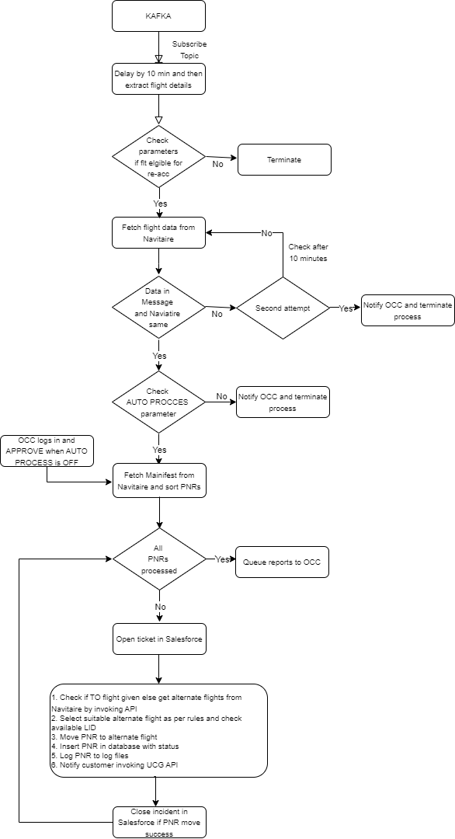

Systems/Technologies

- Database (SQL Server) to store flight and PNR data, rules, users.
- Dot Net for application development.
- React JS for front End.
- Parameters to be stored on JSON.
- Interfaces with Kafka, Navitaire, Database, Salesforce, UCG.
- Integrate with AD account for login validation.
- Compute to be serverless.
- Security and Access control.

